Name:  Class: | ____________________________________  ________________ |  | Date:_________
 | Year 11 Foundations Mathematics  $\frac{ }{30}$  Test 6 - 2019  Topic – Time
Total Time: | 45 minutes
Weighting: | 3%
Equipment: | None

Answer all questions in the space provided.

Question 1 [1, 1, 1, 1= 4 marks]
Complete the following questions.
a) Show 3:10 on the clock face.  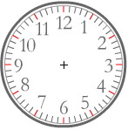  c) Write down the time the following clock shows.    The time is:________________ | b) Show a quarter past 4 on the clock face.    d) Write down the time the following clock shows.  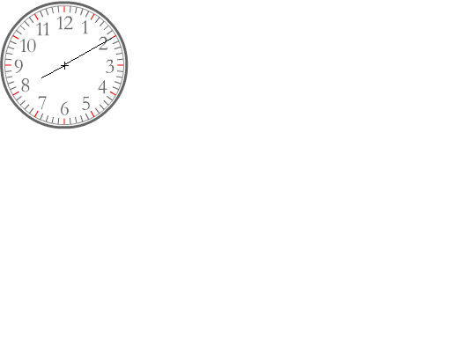  The time is:________________

Question 2 [2 marks]
Select one of the tools listed below, that are used to measure and track time, as the most appropriate to measure the elapsed time for the following events.

Tools: Calendar Clock Stopwatch

- Running 100m in a race
- Working for a day in a work placement
Question 3 [1, 1, 1, 1= 4 marks]
  - Express 245 minutes in hours and minutes.
  - Express 112 seconds in minutes and seconds.
  - What is the time 35 minutes before 9.15am?

  - Express 8 days 15 hours in hours.
Question 4 [half mark each = 4 marks]
Convert the following:
  - 240 seconds = minutes
  - 2.5 minutes = seconds
  - ½ hr = minutes
  - 90 min = hours
  - days = hours
  - 48 hour = days
  - 2 hour = seconds
  - 3 weeks = days

Question 5 [3 marks]
Place the following in order from shortest length of time to longest length of time. Write 1st next to the shortest, then 2nd and then 3rd for the longest event.

Steve completes the following activities in his workout at the gym:

- training circuit that he completes in 12 minutes
- stretches that he completes in 5 minutes
- jogging on a treadmill that he completes in 20 minutes

Question 6 [1, 1, 1, 2 = 5 marks]
For this timetable:

  - To arrive at Lynwood Shopping Centre by 9am what time would you need to catch the bus
at Bull Creek Station?
  - What is the Route Number of the bus you would catch from Bull Creek Station to
Cannington Station?
  - What time does the 507C am route leave Southlands Shopping Centre?
  - How long does the 218A that departs Collins Rd/Rostrata Ave at 7:25am take to get to:
    - Lynwood Shopping Centre?
    - Cannington Station?
Question 7 [1, 1, 1, 1 = 4 marks]
Calculate the time that elapses between the following times.

- 4pm and 11pm _________________________________________________
- 6:30am and 9:40am ______________________________________________
- 5:25pm and 9:33pm ______________________________________________
- 7:52am and 10:28pm _____________________________________________

Question 8 [1, 1, 1, 1 = 4 marks]
Use the calendar to answer the questions.
- How many days are in January?
- What day of the week is January 17?
- How many Mondays are in January?
- Jenny left for a holiday on Wednesday 2nd January and arrived home exactly 2 weeks later. On what date in January did she arrive home?

